附录一、部分专家名单：

丁烈云 院士，华中科技大学

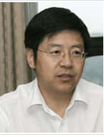

教育部科技委委员及管理学部副主任，中国建筑学会工程管理研究分会理事长，中国金属学会副理事长，住建部工程管理专业评估委员会主任；《土木工程与管理学报》编委会主任，《Automation in Construction》、《Journal of Civil Engineering and Management》、《International Journal of Strategic Property Management》等国际学术杂志编委。

Miroslaw J. Skibniewski 教授，美国马里兰大学

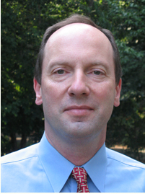

A. James Clark Endowed Chair Professor of Construction Engineering and Project Management in the Department of Civil and Environmental Engineering at the University of Maryland in College Park. Prior to his current appointment he served for 20 years as a faculty member at Purdue University in West Lafayette, Indiana, where he held a position of Professor of Civil Engineering, Construction Engineering and Management. Prof. Skibniewski is also a graduate of the Harvard University Graduate School of Education Management Development Program. Prior to his academic career, he worked in the industry as an engineer with the Pittsburgh Testing Laboratory, a nationwide construction engineering consulting firm in Pennsylvania subsequently renamed to Professional Service Industries, Inc. - where he was in engaged in design quality reviews, construction related claims, value engineering, forensic engineering and industrial safety investigations.

Guillermo Aranda-Mena 教授，澳大利亚皇家墨尔本理工大学

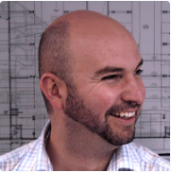

Dr. Guillermo Aranda-Mena is an Associate Professor at the Royal Melbourne Institute of Technology in Melbourne, Australia and he is currently a Visiting Professor at the Politecnico di Milano and recently completed a research placement in Zurich, Switzerland (2012 - 2013). In 2003 he completed his PhD at the University of Reading in the UK and in 2010 he was awarded a professional certificate by the Centre for Integrated Facility Engineering at Stanford University, California. Since 2004 Guillermo lectures at postgraduate level and supervises his PhD team operating in Melbourne and Singapore. His research on Public-Private Partnerships investigates "value for money" in architecture innovation and social infrastructure as well as on the impact of design to lifecycle performance and building operations. Guillermo is a well-published scholar and Regional Editor for Australasia - for 'Facilities' by Emerald Scientific Publishers. Guillermo was one of the first instigators of BIM technologies in the Australian AEC industry. Since moving to Melbourne in 2004 Guillermo managed a number of BIM research, guidelines and policy projects including the National Guidelines for Digital Modelling (2008), Business Drivers for BIM (2007), E-Business in Construction (2005) and Construction Planning Workbench (2004) to mention few.

HaiJiang Li博士，英国卡迪夫大学

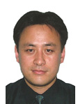

Senior Lecturer - Teaching and Research ，Cardiff School of Engineering

Fellow of British Computer Society

Visiting Professor of Dalian University of Technology, P.R. China

Secretary of European Group for Intelligent Computing in Engineering

Technical Board Member of Building SMART UK

Reviewer for 24 international journals and conferences

Reviewer for Engineering and Physical Sciences Research Council (UK)

Reviewer for Natural Sciences and Engineering Research Council (Canada)

Editorial Member for the journal of Visualization in Engineering

Editorial Member for the Journal of Knowledge and Systems Science

His key expertise lies on the advanced and innovative computing based large scale systems integration and decision making in support of sustainable and resilient complex building / infrastructure monitoring, modelling, analysis, optimization and management. It concerns how to leverage unlimited storage, high power computing, intelligent algorithms with computerized domain knowledge to tackle key environmental challenges.

李恒 教授，香港理工大学

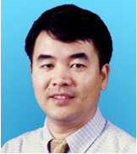

Chair Professor, Research Centre Director for CI, Academic Discipline Leaders of Information and Construction Technology & Virtual Prototyping Laboratory Manager.

Heng started his academic career from Tongji University since 1987. Heng then researched and lectured at the University of Sydney, James Cook University and Monash University before joining Hong Kong Polytechnic University. During this period, Heng have also worked with engineering design and construction firms and provided consultancy services to both private and government organizations in Australia, Hong Kong and China. Heng has conducted many funded research projects related to the innovative application and transfer of construction information technologies, and he has published 2 books, more than 200 journal papers in major journals of his field and numerous conferences papers in proceedings.

Teo Ai Lin教授，新加坡国立大学

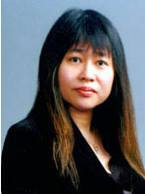

Associate Professor in Department of Building, SDE1-04-07,School of Design and Environment,National University of Singapore

Quantity Surveyor, Senior Quantity Surveyor,Head of Department, Contract Manger, Contruction Companies.

Senior Contracts Engineer, Singapore Technology Construction Pte Ltd

Lecturer, Singapore Polytechnic

Singapore Content Manager, BCI Asia Construction Information Pte Ltd

Senior Manager, School Development Office, Ministry of Education.

Research areas: Carbon Indexing, Sustainable Construction, LCC, Facade Maintenance, Construction Safety & Culture, e-Measurement, BIM,Construction Diversification, Arbitration, Management, Economics & Standards.

古阪秀三 教授，日本京都大学

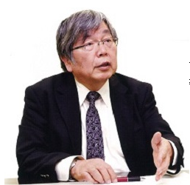

日本建筑管理协会会长、国土交通省·社会资本整备审议会·建筑分科会临时委员、日本建筑综合试验所理事、建筑成本管理系统研究所评议员、日本建筑学会支援建筑会议运营委员会、国土交通省、近畿地方整备局·総合评委委员会委员

研究主题：建筑生产系统研究、项目管理、构建管理研究等

获奖情况：日本建筑学会鼓励奖（论文），1990年9月

[ 2 ]日本建筑学会奖（论文），1999年5月

[ 3 ]建设业振兴基金･感谢状，2005.7.29

[ 4 ]京都自治110周年表彰（京都市长门川大作･）市制的功绩，2008.10.15

[ 5 ]平成22年度特别研究员等审查会专门委员（书面担当）表彰（日本学术振兴会理事长·小野元之），2011.7.31

[ 6 ]（一般社団法人）建设产业专业团体联合会·感谢状，2013.6.4

Chansik Park 教授，韩国中央大学

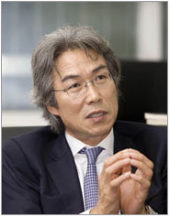

Dr. Chansik Park is a professor of the School of Architecture and Building Science at the Chung-Ang University since 1995, teaching and researching the building construction and construction management discipline. He is teaching 'Building Construction' and 'Building Construction Planning and Scheduling' in the undergraduate program and 'Value Engineering Theory', 'Construction Management Theory', 'Construction Contracting', and 'Special Topics on Construction Management' in the graduate.

In his research laboratory, the Construction Technology Innovation Laboratory (www.contil.org), various research agendas under the theme of 'Innovation of Construction Management Technology' are dealing with graduate students such as Construction Failure, Value Engineering, Construction Safety, Construction Application of IT, Building Construction Education, Construction Project Delivery System, and Global Construction Industry. Recently the CONTIL research team is studying 'Visualized Construction Failure Management System using BIM and Mobile Technology' that is 5-year research project granted by Korea Research Foundation in 2010.